The National UCW executive invites you to
celebrate the 100th Anniversary of the United Church of Canada. Working together we have created this
bulletin and worship service for you to use.

Your National UCW executive

Debra Sparkes-Mercer Margaret Guitard Juanita Andrews
Eileen Butt Betty Ann Watts Ann Piper Debbie Hawkins Marilyn Bubar Valerie Nickson Janice Knowles Charlotte Hoy Betty Turcott Cheryl Mound Nora Darling June Blanchette Susan Mary Williams Lahring Tribe Amy Hill
Anne Reuber Edith Coyle Marilyn Mitchell Mary Dillon Heddys Stevenson Cecilia Grasser Shirley May Joan Zaretsky Diane Thurlow Phyllis Robinson Eleanore Tribe Karen McLennan Margery Wright Shirley McIlwain Kathy Burchill Winnie Kowalewich Patricia Edmonds Win Czum
Carolle Dallas-Arbuckle Cheryl Sullivan

President: Barbara Davison
President Elect: Barb DeJeet
Past President: Nancy Risto
UCW Support Staff at UCC: Angie Musonza

We would like to acknowledge with gratitude the women from; the Presbyterian Church, the Methodist Church, the Congregational Church, who decided to continue their service to God, as part of the United Church of Canada and later became known as the UCW (United Church Women). You have blessed us all.

We would like to thank Carrie Arbuckle Smith for taking our design and turning it into a bulletin cover

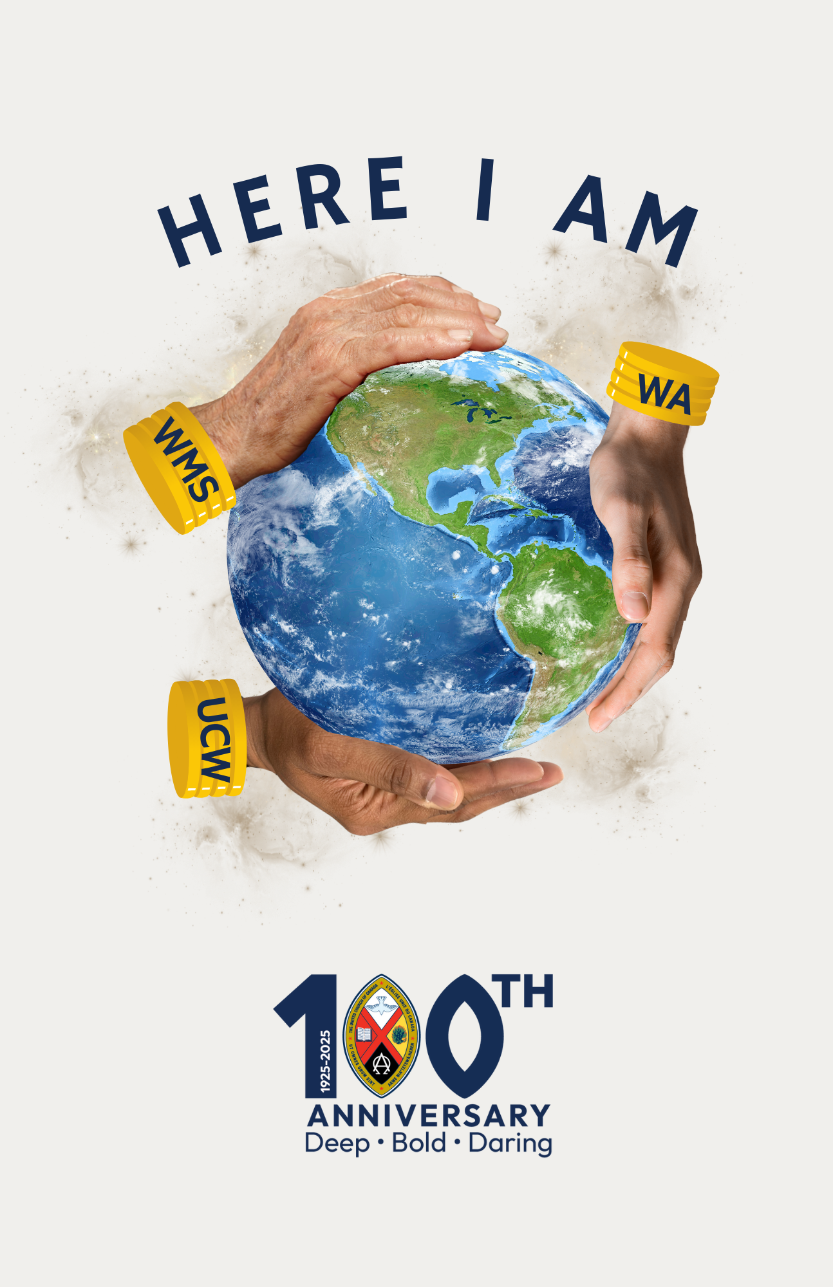

UCW Worship Service for the 100th Anniversary
of the United Church of Canada
“Here I Am”
March 2, 2025

Introit MV 7 ‘Gather Us In’ (has French translation)

Call to Worship
One: Creator God, You call.
ALL: We come as others came before us.
One: You call your people to do your work.
ALL: We come to listen to your call.
One: As our ancestors listened to your call to action one hundred years ago.
ALL: Here we are.

Opening Hymn VU 395 ‘Come In, Come In and Sit Down’

Gathering Prayer
Creator God, we come in search of unity with others and with you. We have not always listened. We have not always heard. We come in gratitude to you for walking with us on our journey. Be with us now as you have with those who have gone before. Be near us as we strive to listen to each other and walk together as one United Church. We welcome all to celebrate God’s presence in their lives. Let us join to be the hands and feet of Christ in the world.

We join our voices in the words of prayer that Jesus taught us to pray…THE LORD’s PRAYER

Children’s Hymn MV 156 ‘Dance With the Spirit’

Children’s Time (optional)

Scripture
1 Samuel 3: 1-19
Matthew 10: 5-15 Bold Discipleship

Reflection: Here We Are!

Hymn VU 509 ‘I, the Lord of Sea & Sky’

Offering

Offering Hymn MV191 ‘What Can I Do’
What can I do? What can I bring?
What can I say? What can I sing?
I’ll sing with joy. I’ll say a prayer.
I’ll bring my love. I’ll do my share.

Offering Prayer
Loving God, You, have given us so much, have called us to use
our time and talents and treasures, united in Your service. Receive
our gifts as an expression of our love for You, and of our loyalty and
devotion to Jesus Christ. May they be used for the total mission of
the United Church responding to Your call to build a new and better
world for tomorrow.

Communion/Agape Meal

Communion Hymn VU 467 ‘One Bread, One Body’

Prayers of the People (VU 909, adapted)

Closing Hymn VU 332 ‘The Church’s One Foundation’

Commissioning

Closing Prayer

Sending VU 964 ‘Go Now in Peace’
Go now in peace, go now in peace.
May the love of God surround you
Everywhere, everywhere you may go.

