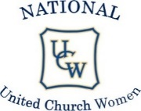
Keeping in Touch

NUCW President’s Message – – “Lead not only by word, but by action”
Hymns: How Firm a Foundation - VU 660 Let us Build a House - MV 1
Scriptures: Nehemiah Ch 2 part of verse 20:
The God of Heaven will help us succeed. We, his servants, will start rebuilding this wall.
1 Corinthians Ch 12 verses 12 – 27: The body is made up of many parts etc.
Prayer: Dear Lord, we ask your blessing and your guidance as we continue our journey to rebuild our firm foundation before it can wear away. Help us, as we take some unexpected journeys in the continuance of your plan for all our hardworking, faithful members of our United Church Women. AMEN.
Barbara Davison: National UCW President


Celebrating 100 Years


UCW Centennial Worship Service for the 100th

The date chosen for the UCW Service is March 2nd, 2025, if it works for your Community of Faith. It can be used on another date as well. The Service is available from the NUCW website (National United Church Women), United Church Website https://united-church.ca/community-and-faith/being-community/united-church-women-ucw Downloads or from any of the executive.

My home church, St. David’s Trinity UC in Saskatoon is participating. Women from all the different church committees are taking part. Phyllis

Ladies Aid was an integral part of the union which formed UCW in ’62. Their work and constant dedication to their churches is well recorded. Ladies Aid began in 1921 as recorded in their minutes. Apologies for missing the Ladies Aid from the Centennial Worship Service Bulletin.

The service was written for everyone in your community of faith. There is a wonderful children’s activity and story.

As of November 2024, the total to date Healing Fund donation is $46,043.57. There is enough in the fund for another program worth $15,000.00 to be chosen in March.

Women’s Inter-Church Council of Canada (WICC) www.wicc.org

Mission “Empowering Christians to pursue justice, peace
and reconciliation by standing together in Prayer and Action”

World Day of Prayer: WDP 2025 Theme “I Made You Wonderful” based on Psalm 139 :14 Worship Service by the World Day of Prayer Committee of Cook Island. Artwork, by mother, daughter duo Tarani and Tevairangi Napa.
- Donations to WDP help to provide grant funding for grass roots programs that support and empower women and children both in Canada and overseas. Donations can be sent electronically or by mails to WICC, 47 Queen St. West, Toronto ON. M5S 2C3
- Lots more information available on the web site
- Fellowship Of the Least Coin. A worldwide ecumenical movement of prayer for peace and reconciliation. Christian women around the world pray with each other. Through this, they are reminded to live a forgiving life with others. ”Least Coins” are given with each prayer, yet the movement is focused on prayer and reconciliation rather than money. Anyone who wishes to join in prayer makes a commitment to uphold, in prayer, those who are victims of Hatred, Violence, and Injustices.
- Ending Violence against women and girls. ‘Thursdays in Black’ pins (20 for $20.00) and other resources are available on the WICC web site
- We-Connect Newsletter, subscribe on website (free)
Check out the web site for more information about any of the above, plus more, www.wicc.org
Blessings: Win Czum (NUCW rep to WICC)

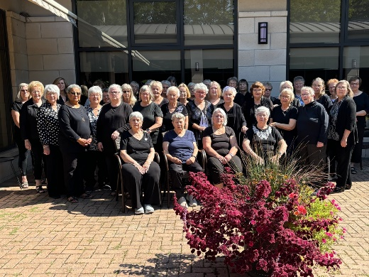
National UCW Support Thursdays In Black
THURSDAYS IN BLACK

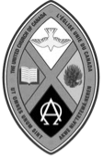
Towards a world without gender-based violence
#ThursdaysInBlack
#JeudisEnNoir
#UCCan

NUCW Alumnae

Alumnae Report – KIT January 2025
Sandra Dunning, a former NUCW President from BC Conference, wrote to share several of her memories of the NUCW.
It was September 2008 and she was travelling from Toronto with Dorothy Amos to Deer Lake, where they were to gather at a lovely resort for the fall meeting of the NUCW Executive. She much appreciated having a ride north with Dorothy as she was no longer able to drive and this time together provided an opportunity for her to catch up on what had been happening at Church House with our organization. Sandra and Reta Manuel had just returned from Korea where they had represented the NUCW at an event with the PROK, the Presbyterian Church of the Republic of Korea. Betty Piper, a past president of Manitou Conference was hosting the fall gathering. They were greeted with a warm, friendly smile and Betty shared that she had purchased plug-in air fresheners to sweeten up the meeting room! Sandra had to ask that these be unplugged and all scented soaps and lotions were also scurried away! Sandra believes we were the leaders of no-scent gatherings as some of our members could not tolerate scents of any kind. It had been the practice at these gatherings to light individual candles as we began our meeting. However, Joyce MacKinnon lit some of her papers on fire! Quick action got those flames out and there were no fire alarms activated! From then on, we settled for one candle only and perhaps a second small flame for those women who were unable to attend. These were always unscented candles and those members with smoke allergies were excused from the room before the flames were snuffed out. The Christ candle Sandra had chosen was unique as the logo on the candle was an ascending dove and this meant there is always a way to find room for all!
I have several more of Sandra’s memories to share in a later issue. I invite all alumnae members to share some of your memories with us. Please contact me if you have any updated addresses, e-mail or snail mail, for alumnae in your region. Blessings and good health to all of you in 2025.
Blessings, Pat Edmonds, Alumnae Rep. patriciaedmonds11@gmail.com

65th Anniversary of National UCW: HEAR OUR VOICE

65th UCW Anniversary July 19 – 23, 2027

Greetings, Bonjour, Sekoh,
In 914 sleeps (as of January 16th), we are hoping many of you are considering joining in the celebrations for our 65th anniversary of the United Church Women, in Ottawa, our nation’s capital, and part of the Eastern Ontario Outaouais Region.
Check out the host hotel – Hilton Garden Inn Ottawa Airport – see everything there is to see in and around the hotel. This will be your “home away from home” for the week. Hotel rates of 2024, $195.00 per night plus tax, have been guaranteed for us in 2027. Hotel reservations will be available in 2026 as will the registration form.
Any questions? Please reach out to us at ucw65anniversary@united-church.ca
Blessings, Kim Baird, Chair

Sask. UCCW Report from Living Skies Region:

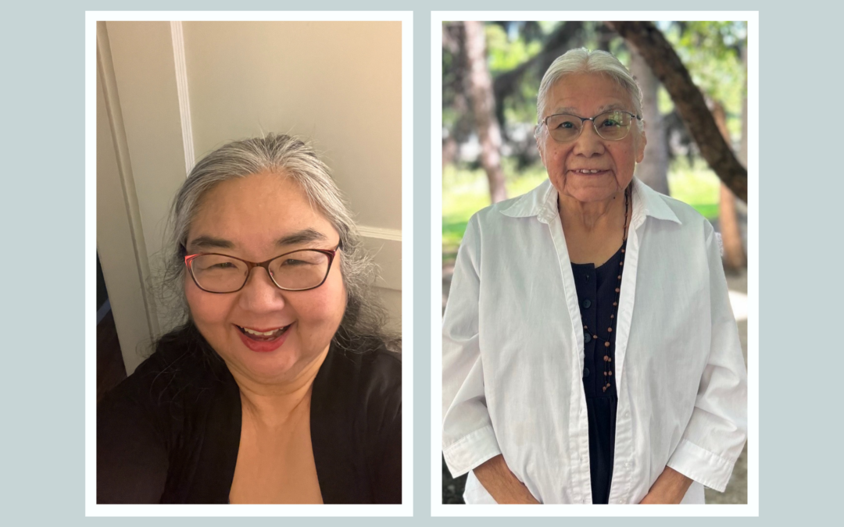
We are very proud and pleased with the announcement from St. Andrew's College in Saskatoon that Rev. Nobuko Iwai and Elder Lorna Standingready will be the recipients of Honorary Doctor of Divinity Awards at the Spring convocation in Saskatoon on May 30. On the recommendation of the Honorary Degree Committee, the Academic Committee of St. Andrew’s College has selected Rev. Nobuko Iwai and Elder Lorna Standingready, to receive a Doctor of Divinity honoris causa degree at the College’s Spring convocation on May 30, 2025, at Christ Church Anglican in Saskatoon.

Rev. Nobuko Iwai is being honoured for her work in pastoral ministry as well as for her social justice work outside of the Church. Nobuko currently serves at Grosvenor Park United Church in Saskatoon, SK. She has also served as Chair of River Bend Presbytery (Saskatoon and area) and President of Saskatchewan Conference, the first person of colour to hold this position. She has served on the Anglican Church United Church Dialogue as well as the General Secretary’s Supervision Committee. She is a trained Educational Supervisor, Interim Minister and Racial Justice Facilitator. Her compassion extends to people in all marginalized communities, in particular those in the gender and sexually diverse community. As stated in her nomination, “Nobuko is able to give the community a vision of what this world would be when we try to understand and love each other.”

Elder Lorna Standingready, of Regina, SK, is being honoured for her work as an elder and long-standing member and partner with The United Church of Canada She is held in the highest regard in terms of her international, provincial and local positions of leadership while also embodying the transformative spirit of Compassion, Light and Love. She is an Elder within The United Church of Canada, an educator of United Church and Canadian history of colonialism, and on how to be in right relations with all peoples, works with Luther College at the University of Regina as Elder-in-Residence as well as Elder in other communities. She also has a longstanding relationship with Regina Multifaith Forum. One letter of support indicated, “Lorna’s dedication to community, to building bridges, to supporting and honouring residential school survivors and their families, to building up the church in love is endless.” Elder Lorna Standingready has also served on the executive of the National United Church Women as the female elder representative from the All Native Circle (under the former structure of the United Church) at National UCW meetings held in in Mississauga, Ontario.

Our Sask. UCCW executive will meet by zoom later in January to plan for a one-day Women's Gathering in Saskatoon on Saturday, April 26 at St. David’s Trinity United Church.
There will also be a one-day Women's Event in Abbey on Tuesday, June 10.
Then on June 20 – 22 a Women's Camp for all women in the Living Skies Region will be held at Camp Tapawingo at Candle Lake.

Blessings, Mary Mohn on behalf of Sask. UCCW

EOOR Leadership Report

Another amazing Leadership Day was held on October 2, 2024 in Smiths Falls.
The Two sessions of the day were hosted by Lois Leroux and Elaine Farley . They covered the topics “How to take minutes” and “What to save for the Archives”.
Information was shared, handouts given out and questions answered. People went home to share the information with their church boards and UCW,s.
There was a huge turn out of representatives from all across the Region. Best Leadership Day to date with 35 attending.
Thank you to the two ladies for sharing their gifts.

Charlotte Hoy, President of EOOR UCW
Horseshoe Falls Region UCW - Called to be the Church

As the new year begins, UCW units within Horseshoe Falls Region are eagerly anticipating the date later in Jan for our rebooked Fall Gathering. Originally slated for November, our guest speaker Moderator Lansdowne had a last minute conflict that meant a new date had to be chosen. The event is being hosted via the ZOOM video platform, some units will be hosting 'watch parties' to share fellowship and accommodate those members who don't have access technology to support digital communication. A great way to start the new year.
A survey of fall activities across the units in the region showcased the many ways the vital work of the UCW is being carried out in their churches and their communities. Taking inspiration from Moderator Lansdowne's Advent message drawn from Psalm 96, “Sing to the lord a new song, Sing to the lord, all the earth”, the HFR UCW executive encourage all units to take heart when faced with the challenge of change, to find strength in a ‘new song’, and to sing it out as continue to be 'called to be the church'. Plans are currently underway for the region's annual spring gathering, hosted this year at Stamford United in Niagara Falls.

Wanda Backus-Kelly HFR UCW president

East Central Ontario Region UCW

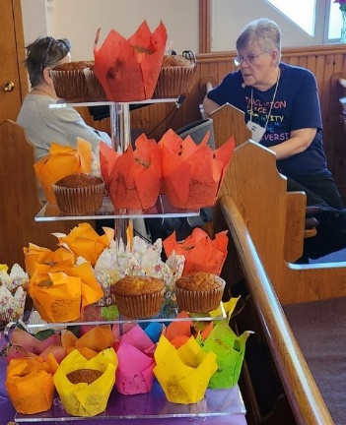
Every two years, our Regional UCW sends a UCW representative on a Cross-Cultural Experience. On November 20 at St Mark’s, Cannifton, our Regional UCW held its annual Midweek Event, we celebrated our Region’s long-standing partnership with its Mission Partners in El Salvador– Iglesia Baptiste Emmanuel. What made this ‘pilgrimage’ such a profound experience? UCW Rep, Lyn Miller, said, “It was the people.” Her slideshow and video of the people they met made us feel that we, too, had met the people of El Salvador. It was a very moving experience and a joy to witness their commitment and to realize that we have been part of that work. One comment; “I had no idea our church did this kind of thing.”

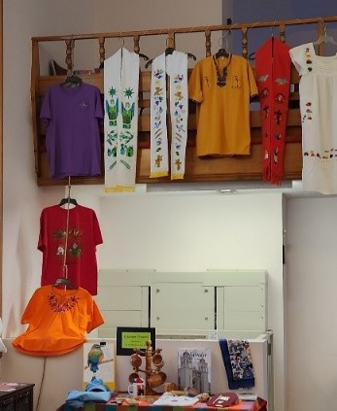
About 70 women gathered at Midweek to learn from displays, singing hymns in Spanish, a meal of typical El Salvador food. A panel of youth/adults who had been part of the group of 30 who visited El Salvador during the 2024 March Break gave witness to the effect the trip had on their lives. Iglesia Baptiste Emmanuel and their school make life-changing differences to youth in a district of their capitol city known for gang and street violence. Much gratitude was expressed not just for our gifts of funds and supplies such as the laptop donated this year, but even more for the way that the UCW spreads the word about the amazing work the United church does through working with M&S partners.
The Winter Season is a time for gathering hope and energy for the New Year. Our 5 Area UCWs are preparing for their Annuals in the months prior to our Regional UCW AGM on April 10 in Peterborough. There were a number of new faces on the executive this year, including Carolyn Vanhorne-Coffey in her first year as Treasurer of East Central Ontario Region UCW. We look forward to additional new faces and continuing good spirit in 2025. 2025 marks the 10th Anniversary of our becoming an Affirming Ministry, first as Bay of Quinte Conference UCW and renewed as East Central Ontario Region UCW. Much to celebrate in this 100th Anniversary year for the church.
Cheryl Mound President
Eastern Central Ontario Region UCW

UCC East Grace United Women, Caledonia ON

The UCW would like to recognize one of our own with a Lifetime Award Pin. Eva Lynn joined the UCW after retiring from nursing in the 1990’s. In 2003 Eva agreed to be UCW President for a one or two year appointment. Little did she know she would remain as President for 20 years. During her time she ran the meetings, became part of the Grace quilting group, made fruit and meat pies, helped with the catering events as well as worked our Bazaar and House Tour projects, just to name a few of the things she did. Eva was usually one of the first to sign up for activities when needed. In her 90th year, 2024, Eva decided it was time to have someone else step into the role. The UCW are happy and honoured to present this pin to Eva for all her time and dedication to our Grace Caledonia UCW Unit.
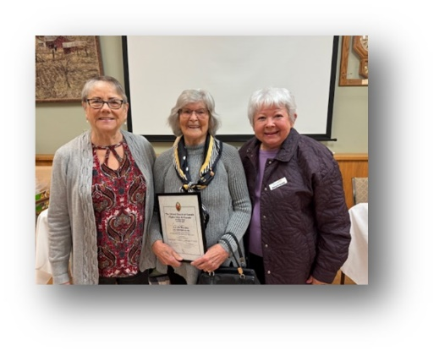
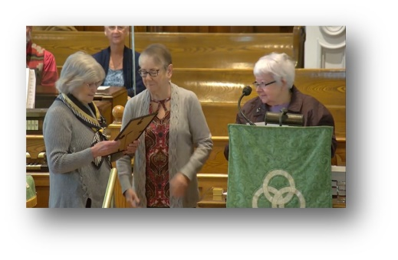

Grace's UCW President Donna Tansley, Eva Lynn, and Marg Crawley our Region Rep and Treasurer.

Kind regards, Teresa Harrow

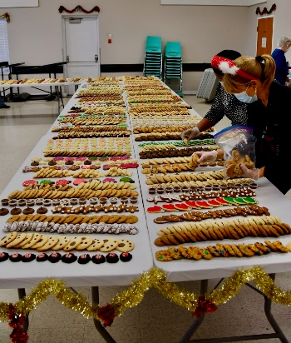
Glen Cairn United Church, Kanata ON

32nd Annual Christmas Cookie Walk, Crafts, Tea Room, and Silent Auction held on December 7 at Glen Cairn United Church, Kanata (Ottawa), ON.

In 2020 we suspended this event and in 2021-2023 we had a smaller event where people could order cookies online, we would package boxes with a variety of cookies, and then they would drive up at certain times and we would hand them their cookies.

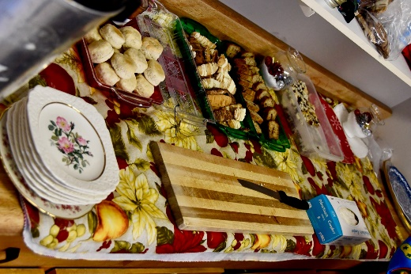
In 2024, we decided to go back to the traditional way. The cookies were laid out on tables, people lined up, and starting at 9 am we would let people into our Hall with a glove and a mask (new) and pick out the cookies that they wanted.

We also had 4 crafters with their handmade items plus UCW crafts, preserves, and Christmas items for sale. A tearoom was available for those who wanted to sit and rest for a awhile. And a silent auction room.

Martha Townshend Colford
UCW President Glen Cairn United Church

First Dawn Eastern Edge Area Newfoundland and Labrador

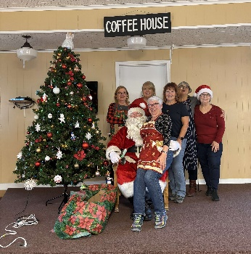
Old Perlican UCW offers Brunch with Santa every December and 2024 was no different. Offering a time for fellowship, food, fun and a visit from Santa, this event is well received by community families. Proceeds are donated to Ronald McDonald House in St. John's.
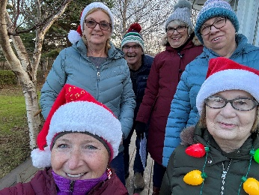
Pat March, Tina Barrett, Pat March,
Wendy Tizzard, Fran Button, Wayne Button
Margaret Guitard & Judy Fran Button
Meadus, Judy Meadus Wendy Tizzard Margaret Guitard

Early December heralds decorating our sanctuary and hall, baking mini fruit cakes to deliver as we go carolling throughout our community, ending with a visit to the local retirement home. Always a fun afternoon that brings joy to so many of our seniors. We are accompanied by our Church music director/choir leader, Wayne Button, who provides his gift of music on his guitar and leads us in song.
Blessings, Margaret Guitard
Old Perlican UCW
First Dawn Eastern Edge Area
Newfoundland & Labrador

Facebook: National United Church Women

Come check out our Facebook page. Like our page. Send me pictures (with permission from everyone in the photo to use), events and what is going on within your Community of Faith. Go to your Facebook page, in the upper left hand corner under search friends type National United Church Women and you will be in. Our communications email is nucwcanada@gmail.com
Phyllis Communications Chair NUCW

Pacific Mountain UCW

Women's Advent Service at Peninsula United Church Surrey, BC

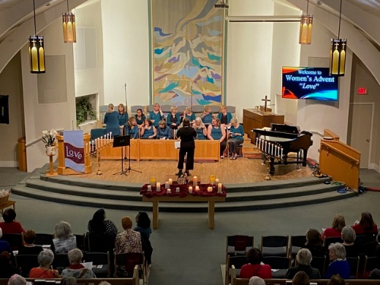
For over 30 years, women from the neighbouring community have gathered to celebrate Women’s Advent on the first Monday of Advent. This year the service was held at Peninsula United Church in Surrey, BC held on Monday, November 25, 2024. The theme was "Love".

With the support and collaboration of the UCW, Peninsula United Church offers many of these visitors to our church a lovely evening of fellowship, hospitality, music and an inspirational message. It is truly lovely to have the church filled with the voices of over 200 women sharing fellowship on this special evening. Everyone looks forward to the warm cider, yummy cookies, lovely music, and motivational message with their friends and acquaintances from the wider community—a wonderful annual event!

Here’s the link to experience our Women’s Advent Service:
https://www.youtube.com/watch?v=y1Azg5jsURg
In peace, Winnie Kowalewich,
President Pacific Mountain UCW

Mystery Question???

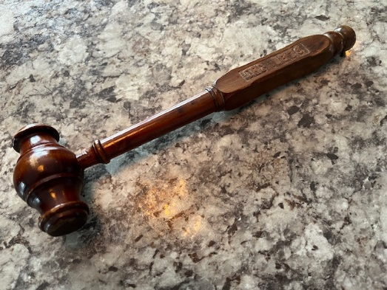
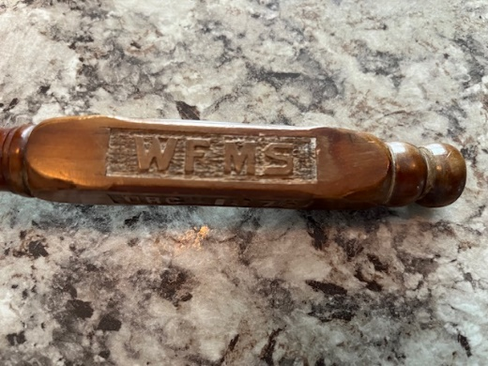
Your mystery question:
What is this and where did it come from?
What is the relevance to UCW?
Best guesses and the correct answer will be in the next issue of Keeping In Touch.

If you have any special gifts given to your UCW, please send pictures and a write up.

A charter and life member of the UCW from Living Skies passed away on New Year's Day. She had a special phrase that she loved to share.
ALWAYS REMEMBER: GOD ANSWERS “KNEEL-MAIL”
Advent Pictures 2024
This is just a few of the pictures. More can be seen on our Facebook page – National United Church Women.

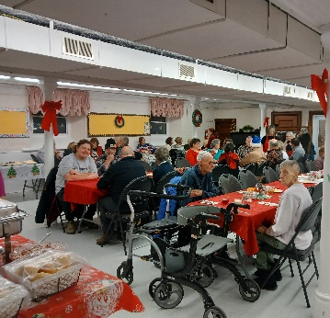
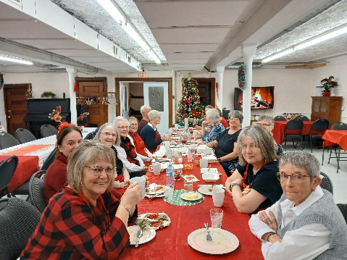
Community Christmas
Dinner 2024
Beachburg, ON

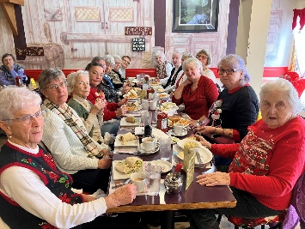
Trinity St Stephen’s UC
Amherst, NS
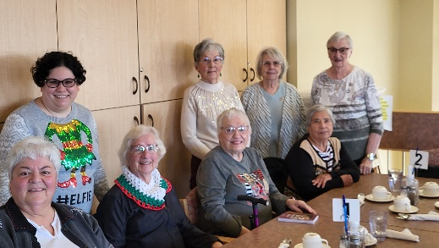

Mount Royal Emmanuel UCW Advent Lunch
Saskatoon, SK

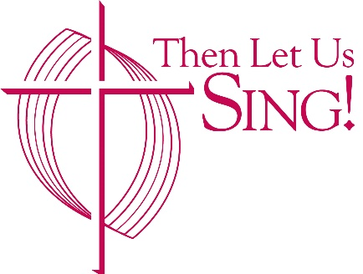
Coming Soon: Then Let Us Sing!

TLUS The release of Then Let Us Sing! — the United Church’s new digital music resource—is getting closer. Final selection of the new hymns and songs has been made, final layout and design is in process, and the digital platform in process.
Workshops and training sessions are planned in the new year to introduce Then Let Us Sing! across the country. Keep an eye open for news about events in your area. For more information, visit www.thenletussing.ca and subscribe to the newsletter for updates. And don’t forget to visit (and like!) our Facebook page.

Deadline for submission for our June ‘Keeping in Touch’ issue is June 15, 2025.
Include with your submissions information about the 100th Anniversary Celebrations, how the NUCW Worship Service was used, and women of your faith communities. nucwcanada@gmail.com

